**Boxplots of the true label and predicted label to IODP-Expedition 362, site U1481 (G3 group)**

Note: log parameters values have been normalized range 0 and 1 using minimum and maximum scalar function. The use of this function is due to a better presentation of the box viewing all within the same range and format.

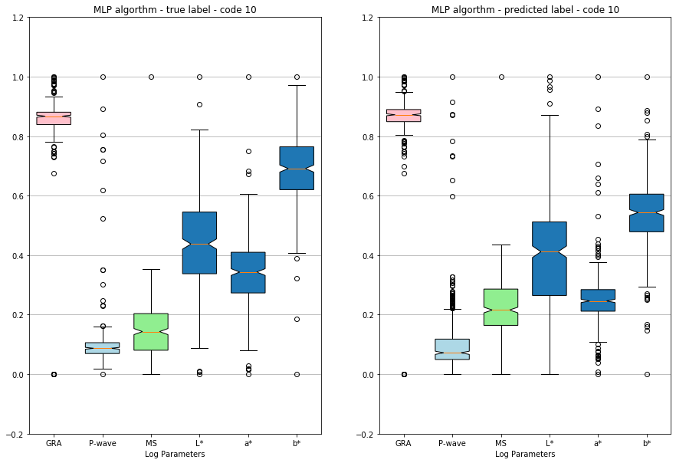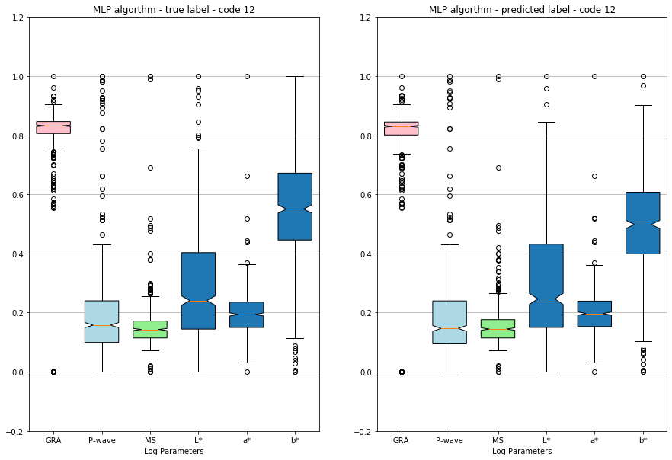

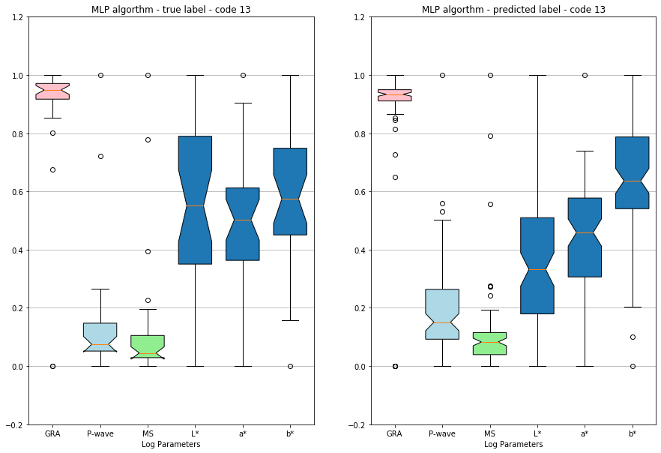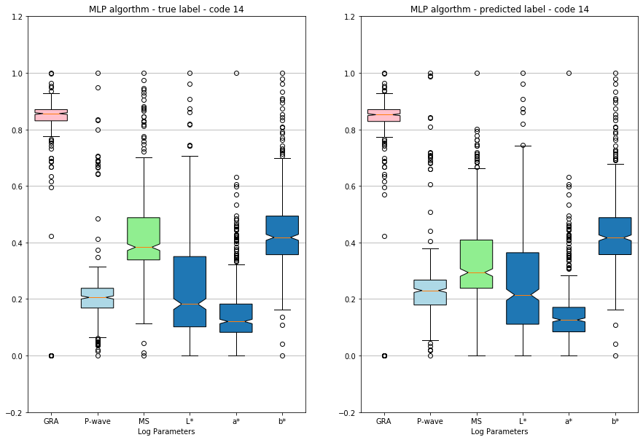

Figure 1 Graphical representation boxplot true label and predicted label, MLP algorithm, code 10 (referring to Litho1), code 12 (referring to Litho3), code 13 (referring to Litho4) and code 14 (referring to Litho5). Lithology Code 11 and Lithology Code 15 are not recorded in this hole range (Al-Mudhafar, 2016).

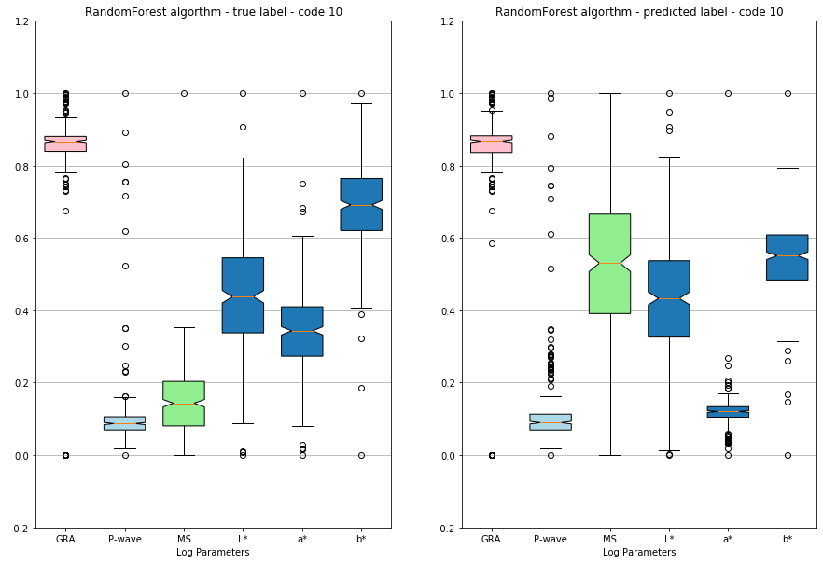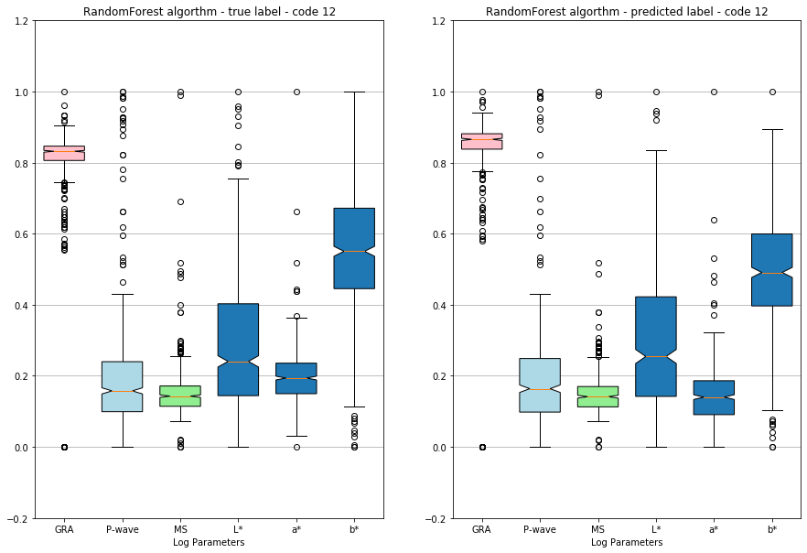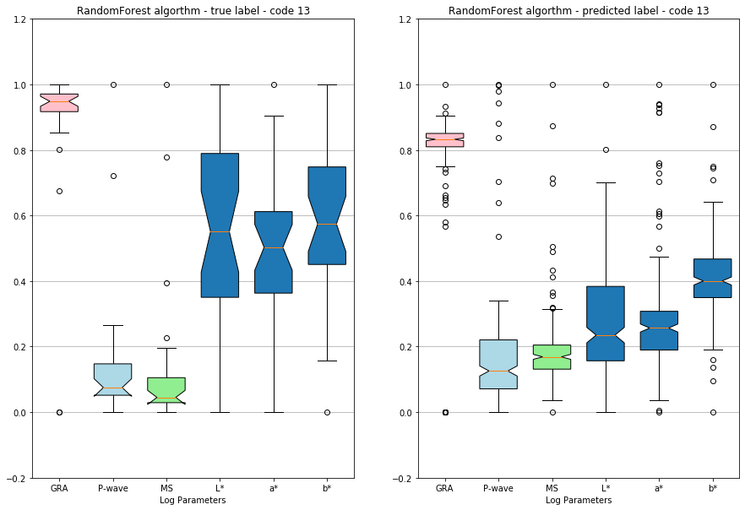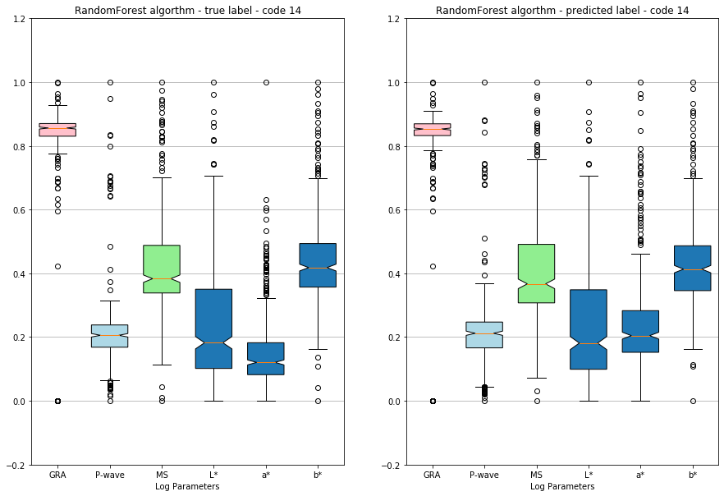

Figure 2 Graphical representation boxplot true label and predicted label, RandomForest algorithm, code 10 (referring to Litho1), code 12 (referring to Litho3), code 13 (referring to Litho4) and code 14 (referring to Litho5). Lithology Code 11 and Lithology Code 15 are not recorded in this hole range (Al-Mudhafar, 2016).

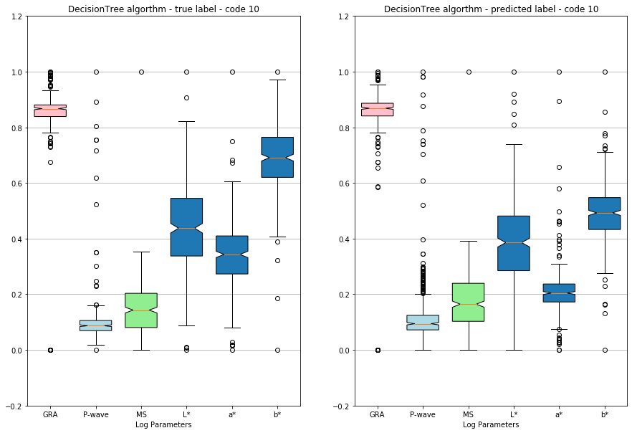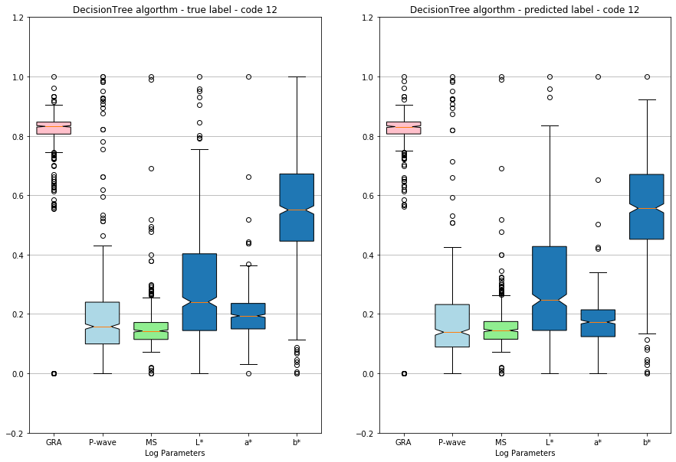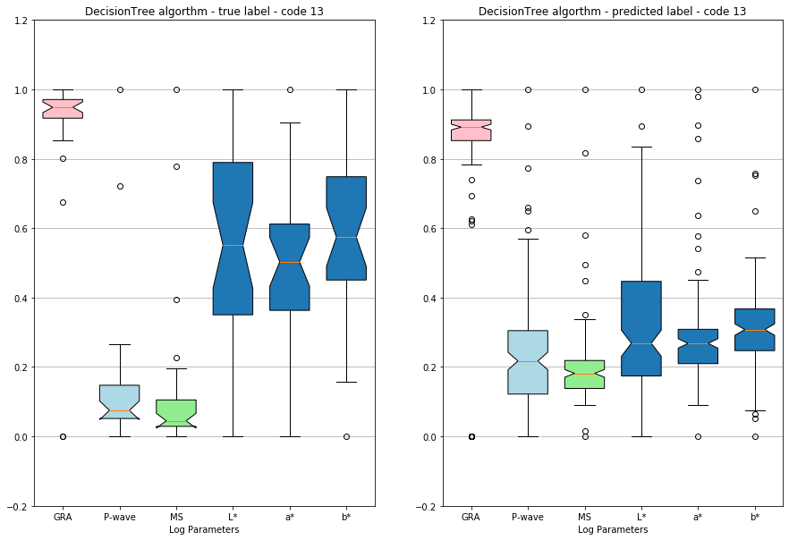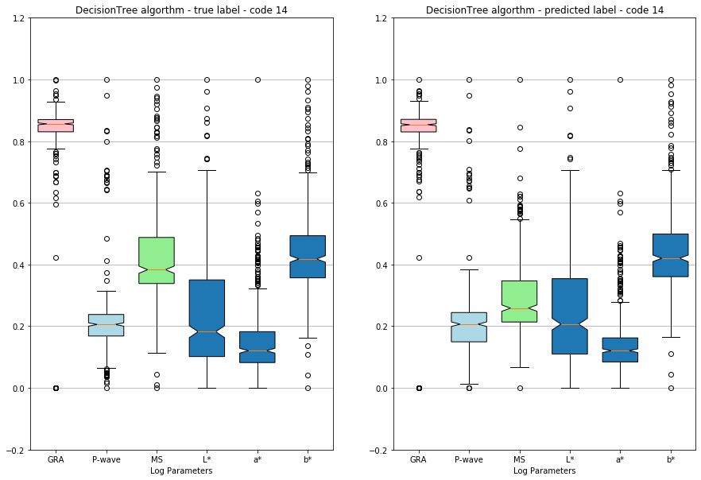

Figure 3 Graphical representation boxplot true label and predicted label, DecisionTree algorithm, code 10 (referring to Litho1), code 12 (referring to Litho3), code 13 (referring to Litho4) and code 14 (referring to Litho5). Lithology Code 11 and Lithology Code 15 are not recorded in this hole range (Al-Mudhafar, 2016).

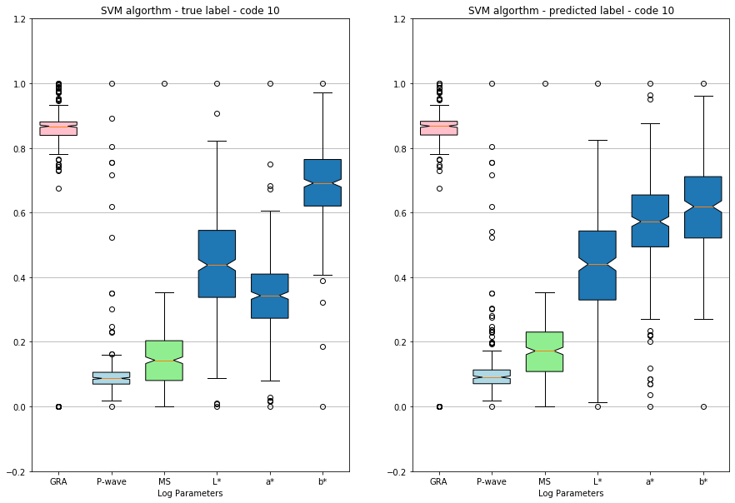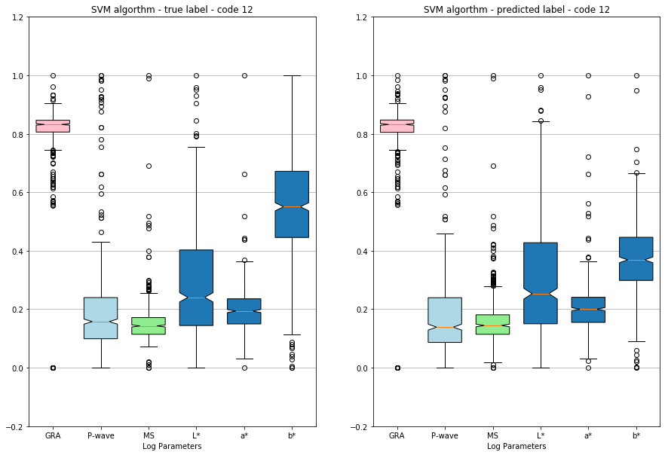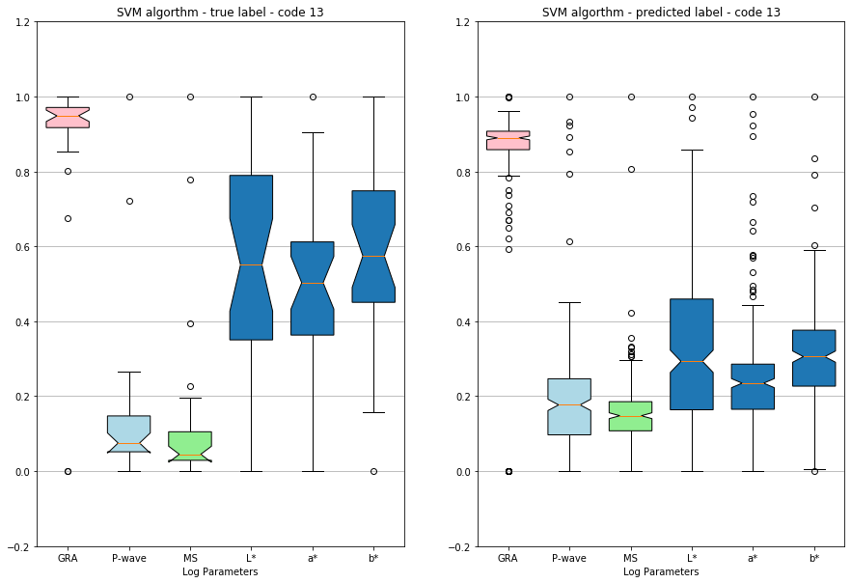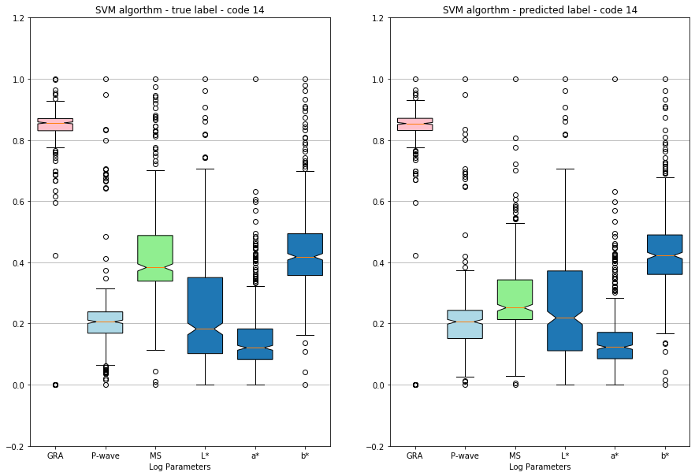

Figure 4 Graphical representation boxplot true label and predicted label, SVM algorithm, code 10 (referring to Litho1), code 12 (referring to Litho3), code 13 (referring to Litho4) and code 14 (referring to Litho5). Lithology Code 11 and Lithology Code 15 are not recorded in this hole range (Al-Mudhafar, 2016).

**References**

Al-Mudhafar, W. J., 2016. Applied Geostatistical Reservoir Characterization in R: Review and Implementation of Rock Facies Classification and Prediction Algorithms-Part I. Offshore Technology Conference. doi:10.4043/26947-MS.